# **SEIGMA SHINY APPS - ECONOMIC**

## Update Datasets for Current Apps March 20, 2018

### Things to Consider

#### Inflation Adjusted Dollar

* Adding any new $ amounts requires an updated inflation adjusted dollar calculation
  + Divide a monetary time series by a price index, such as the Consumer Price Index (CPI) to report in constant dollars rather in current dollars
* Data downloaded from Bureau of Labor Statistics (<http://data.bls.gov/cgi-bin/srgate>) with series id: CUUR0000SA0 (U.S. city averages) – Consumer Price Index-All Urban Consumers
* See instructions and tables saved in J:\Projects\Gambling\SEIGMA\Data Management Center\SECONDARY DATA\MISC\Inflation adjusted dollar
* Most current file: *CPI-U_2000-2017.xlsx*
* A description of how to do this is contained in Brook’s note about updating Property Values data: J:\Projects\Gambling\SEIGMA\Data Management Center\SECONDARY DATA\INCOMING economic\housing-real estate\UPDATING ASSESSED PROPERTY VALUES
* Also there is a note from previous RAs on updating inflation adjusted dollar amounts: J:\Projects\Gambling\SEIGMA\Data Management Center\SECONDARY DATA\MISC\Inflation adjusted dollar

#### Updated Population Counts

* Provided by UMDI: Population of Massachusetts Cities, Towns, & Counties: Census Counts and Estimates, 2010-2016 (J:\Projects\Gambling\SEIGMA\Data Management Center\SECONDARY DATA\INCOMING economic)
* Additional Datasets: <https://www.census.gov/data/datasets/time-series/demo/popest/intercensal-2000-2010-cities-and-towns.html> and <https://www.census.gov/data/datasets/2016/demo/popest/total-cities-and-towns.html> (this one shows same data as UMDI file above); both files are in folder listed above

### Building Permits (AR002_01)

Archived data for Building Permits app: J:\Projects\Gambling\SEIGMA\Data Management Center\SECONDARY DATA\FINAL\AR002\Archive

Downloaded data from:

* MassBenchmarks (<http://www.massbenchmarks.org/statedata/data.htm>) (via Bureau of Labor Statistics)
* Link: [Annual building permit data for all cities and towns, from Census Bureau Construction Statistics, 2000–2016](http://www.massbenchmarks.org/statedata/data/building_permits_2000-2016.xlsx)
* Downloaded dataset for 2000-2016
* Saved: J:\Projects\Gambling\SEIGMA\Data Management Center\SECONDARY DATA\INCOMING economic\housing-real estate as *building_permits_2000_2016.xlsx*

Other data

* Updated population counts for calculating permits per 1000 population
* Updated CPI-U data to calculate inflation adjusted dollars

### Employment (AP003_01)

Archived data for Employment app: J:\Projects\Gambling\SEIGMA\Data Management Center\SECONDARY DATA\FINAL\AT003\Archive

Downloaded data from:

* MA Office of Labor and Workforce Development (OLWD), Labor Market Information
* Link: <http://lmi2.detma.org/lmi/lmi_es_a.asp>
* Downloaded dataset for 2001-2016
* Saved: J:\Projects\Gambling\SEIGMA\Data Management Center\SECONDARY DATA\INCOMING economic\resident Indicators\OLWD_MA as *OLWD_employment_MA towns_2001-2016.xlsx*

### Unemployment (AT004_01)

Archived data for Unemployment app: J:\Projects\Gambling\SEIGMA\Data Management Center\SECONDARY DATA\FINAL\AT004\Archive

Downloaded data from:

* US Department of Labor, Bureau of Labor Statistics, Local Area Unemployment Statistics (LAUS)
* Link: <https://www.bls.gov/lau/data.htm>
* Downloaded dataset for 2001-2016
* Saved: J:\Projects\Gambling\SEIGMA\Data Management Center\SECONDARY DATA\INCOMING economic\resident Indicators\LAUS as *LAUS_MA_2001-2016.xlsx*

### Labor Force (AT004_01)

Archived data for Labor Force app: J:\Projects\Gambling\SEIGMA\Data Management Center\SECONDARY DATA\FINAL\AT004\Archive

Downloaded data from:

* US Department of Labor, Bureau of Labor Statistics, Local Area Unemployment Statistics (LAUS)
* Link: <https://www.bls.gov/lau/data.htm>
* Downloaded dataset for 2001-2016
* Saved: J:\Projects\Gambling\SEIGMA\Data Management Center\SECONDARY DATA\INCOMING economic\resident Indicators\LAUS as *LAUS_MA_2001-2016.xlsx*

### Property Tax (AW002_02)

Archived data for Property Tax app: J:\Projects\Gambling\SEIGMA\Data Management Center\SECONDARY DATA\FINAL\AW002\Archive

Downloaded data from:

* MA Department of Revenue, Division of Local Services, Municipal Databank, Tax Levy and Tax Rate by Class
* Link: <https://dlsgateway.dor.state.ma.us/reports/rdPage.aspx?rdReport=Dashboard.TrendAnalysisReports.TaxLevyByClass> and <https://dlsgateway.dor.state.ma.us/reports/rdPage.aspx?rdReport=PropertyTaxInformation.taxratesbyclass.taxratesbyclass_main>
* Downloaded dataset for 2013-2017
* Saved: J:\Projects\Gambling\SEIGMA\Data Management Center\SECONDARY DATA\INCOMING economic\housing-real estate\Property Tax as *taxlevybyclass_xxxx* and *taxratesbyclass_2013-2017.xlsx*

### ACS 5-year Household Income (AT003_03) – Inflation Adjustments

Archived data for Household Income app: J:\Projects\Gambling\SEIGMA\Data Management Center\SECONDARY DATA\FINAL\AT003\Archive

Data currently in Household Income app does not adjust for inflation. The Census has published guidance on how to adjust multiyear estimates over time in *A Compass for Understanding and Using American Community Survey Data* (J:\Projects\Gambling\SEIGMA\Data Management Center\SECONDARY DATA\ASC Table DP02\ACS info\ACSGeneralHandbook.pdf).

Here is the handbook excerpt (Appendix A-23):

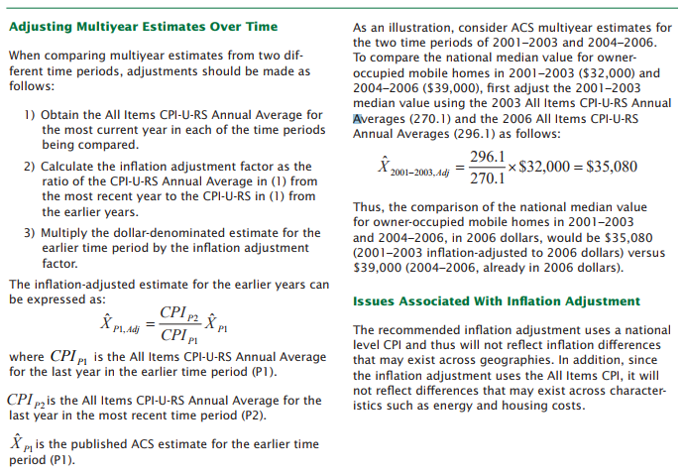

CPI-U-RS file saved: J:\Projects\Gambling\SEIGMA\Data Management Center\SECONDARY DATA\MISC\Inflation adjusted dollar as *CPI-U_RS_allitems_1977-2016.xlsx*